**Supplementary Materials**

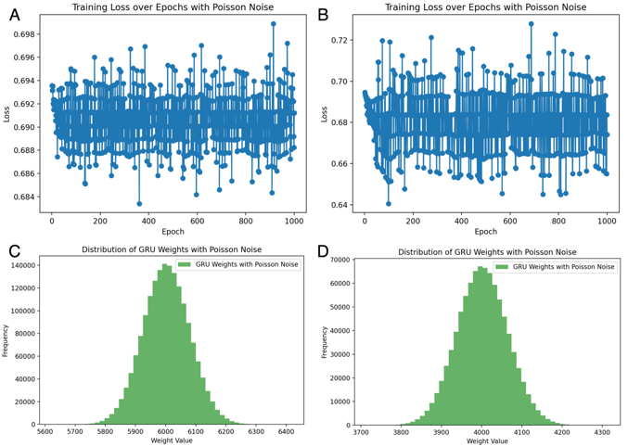

Fig. 1. Training Loss Over Epochs with Poisson Noise and Biased Distribution of GRU Weights Suggest Suboptimal Learning and Performance in ASD and NASH Disease Models. (A) Training Loss over Epochs with Poisson Noise for Disease ASD. (B) Training Loss over Epochs with Poisson Noise for Disease NASH. (C) Distribution of GRU Weights with Poisson Noise for Disease ASD. (D) Distribution of GRU Weights with Poisson Noise for Disease NASH. The inclusion of Poisson noise in the datasets impacts the training process by slowing the convergence rate of the model's training loss, indicating challenges for the network in adapting to the noisy data. This effect may cause the model to oscillate between multiple local minima, leading to instability during training. Additionally, the GRU weight distribution becomes skewed, suggesting non-uniform parameter updates, where certain weights receive disproportionately large adjustments. This uneven weighting can result in the model overemphasizing specific features while overlooking others of equal importance, ultimately affecting classification performance.

**Boxplot Analysis**

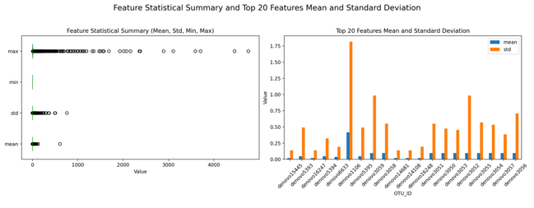

Fig. 2. Statistical analysis of ASD-Son dataset features and display of mean and standard deviation of key features.

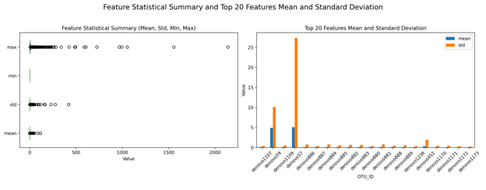

Fig. 3. Statistical analysis of ASD-Kang dataset features and display of mean and standard deviation of key features.

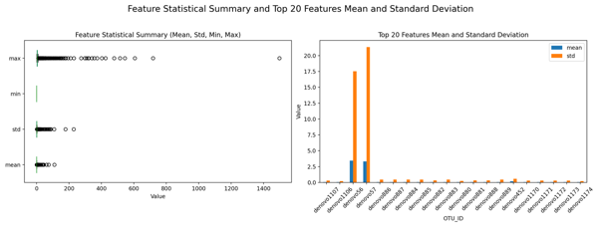

Fig. 4. Statistical analysis of CRC-Xiang dataset features and display of mean and standard deviation of key features.

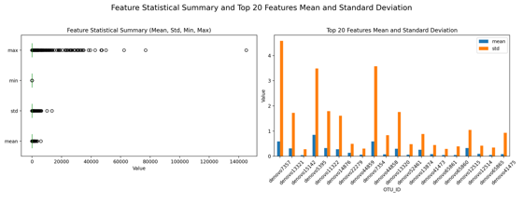

Fig. 5. Statistical analysis of CRC-Zeller dataset features and display of mean and standard deviation of key features.

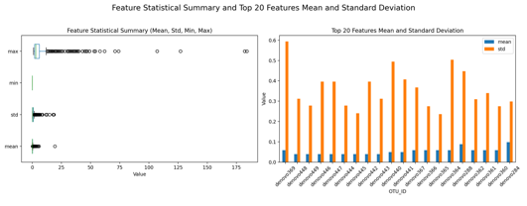

Fig. 6. Statistical analysis of CRC-Zhao dataset features and display of mean and standard deviation of key features.

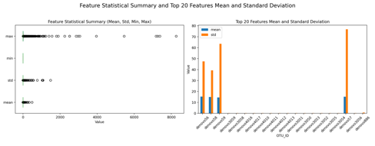

Fig. 7. Statistical analysis of CDI-Vincent dataset features and display of mean and standard deviation of key features.

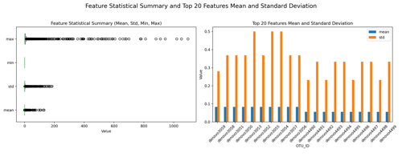

Fig. 8. Statistical analysis of HIV-Dinh dataset features and display of mean and standard deviation of key features.

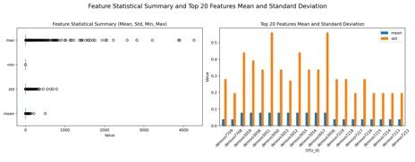

Fig. 9. Statistical analysis of HIV-Lozupone dataset features and display of mean and standard deviation of key features.

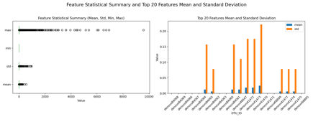

Fig. 10. Statistical analysis of IBD-Gevers dataset features and display of mean and standard deviation of key features.

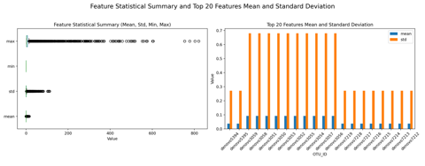

Fig. 11. Statistical analysis of NASH-Chan dataset features and display of mean and standard deviation of key features.

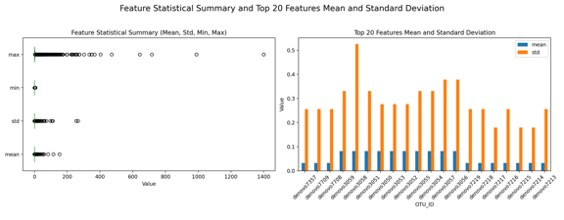

Fig. 12. Statistical analysis of OB-Jumpertz dataset features and display of mean and standard deviation of key features.

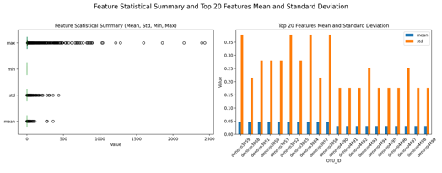

Fig. 13. Statistical analysis of OB-Ross dataset features and display of mean and standard deviation of key features.

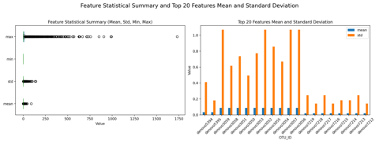

Fig. 14. Statistical analysis of PAR-Scheperjans dataset features and display of mean and standard deviation of key features.

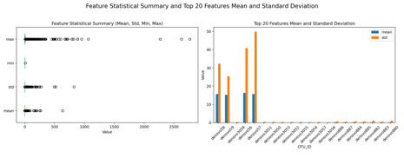

Fig. 15. Statistical analysis of T1D-MejiaLeon dataset features and display of mean and standard deviation of key features.

**Density Estimation Plot Analysis**

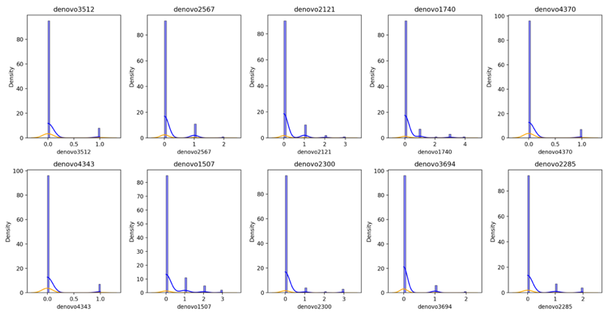

Fig. 16. Kernel Density Estimation of the Top Ten Features in the ASD-Son Dataset

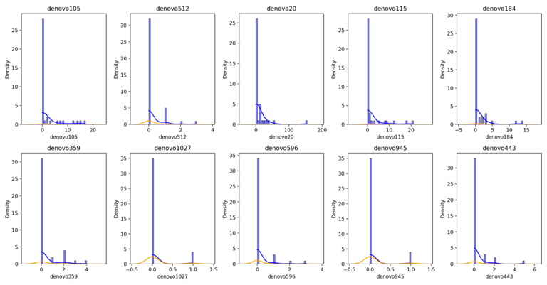

Fig. 17. Kernel Density Estimation of the Top Ten Features in the ASD-Kang Dataset

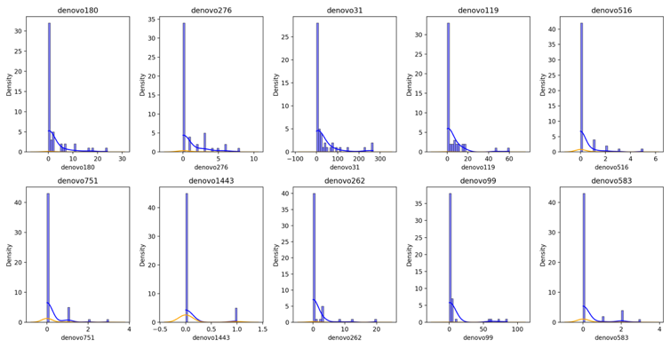

Fig. 18. Kernel Density Estimation of the Top Ten Features in the CDI-Vincent Dataset

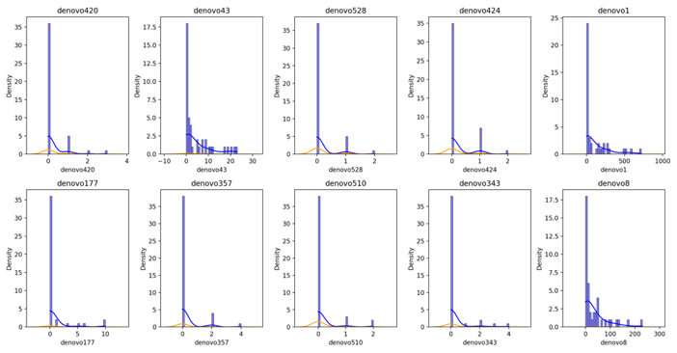

Fig. 19. Kernel Density Estimation of the Top Ten Features in the CRC-Xiang Dataset

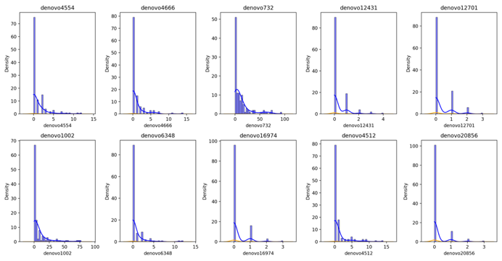

Fig. 20. Kernel Density Estimation of the Top Ten Features in the CRC-Zeller Dataset

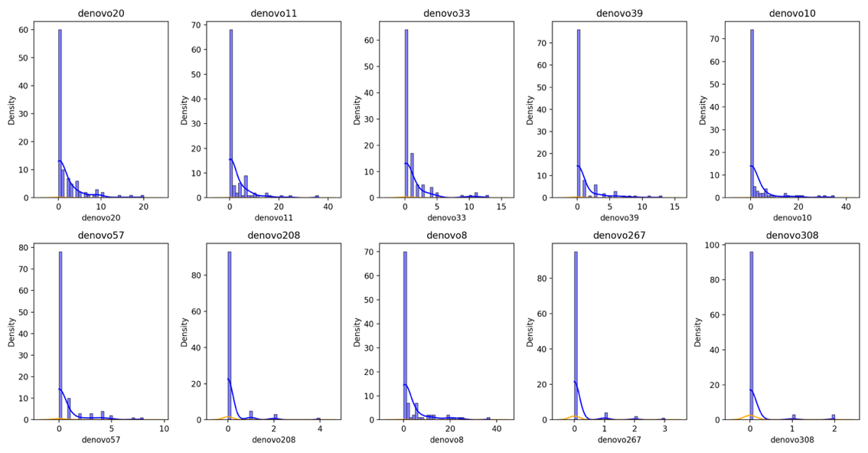

Fig. 21. Kernel Density Estimation of the Top Ten Features in the CRC-Zhao Dataset

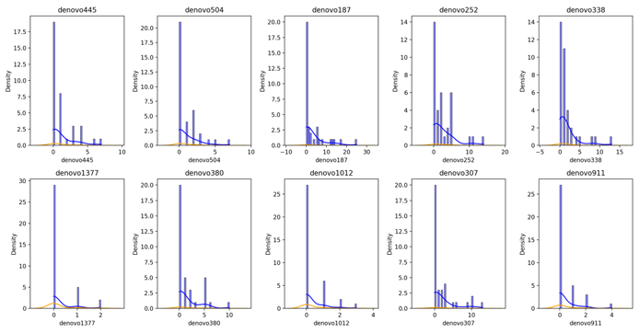

Fig. 22. Kernel Density Estimation of the Top Ten Features in the HIV-Dinh Dataset

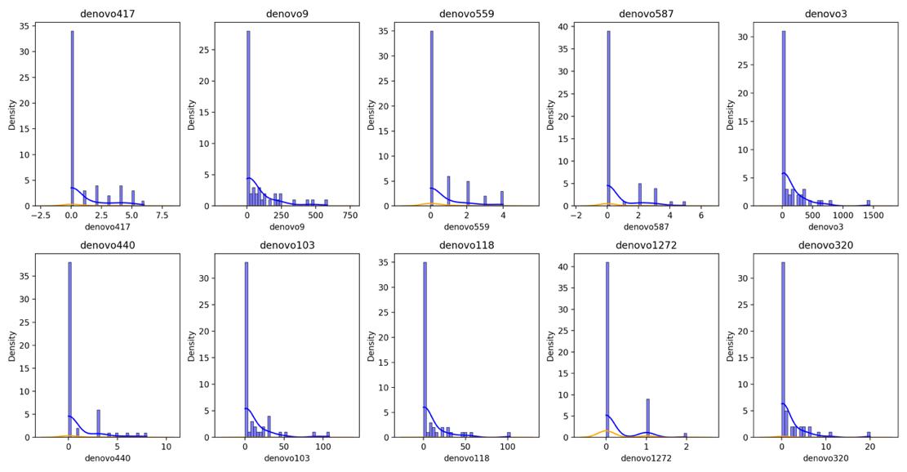

Fig. 23. Kernel Density Estimation of the Top Ten Features in the HIV-Lozupone Dataset

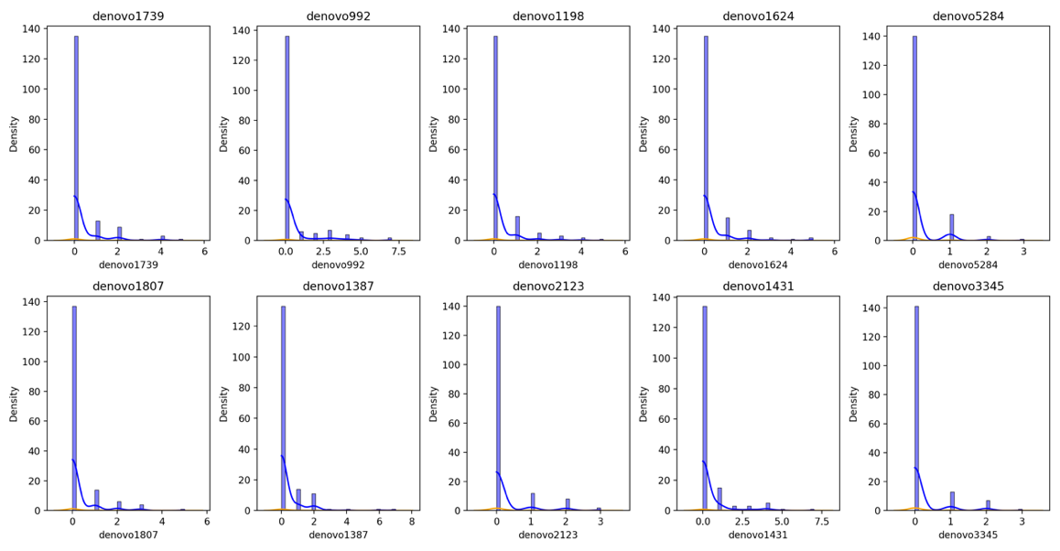

Fig. 24. Kernel Density Estimation of the Top Ten Features in the IBD-Gevers Dataset

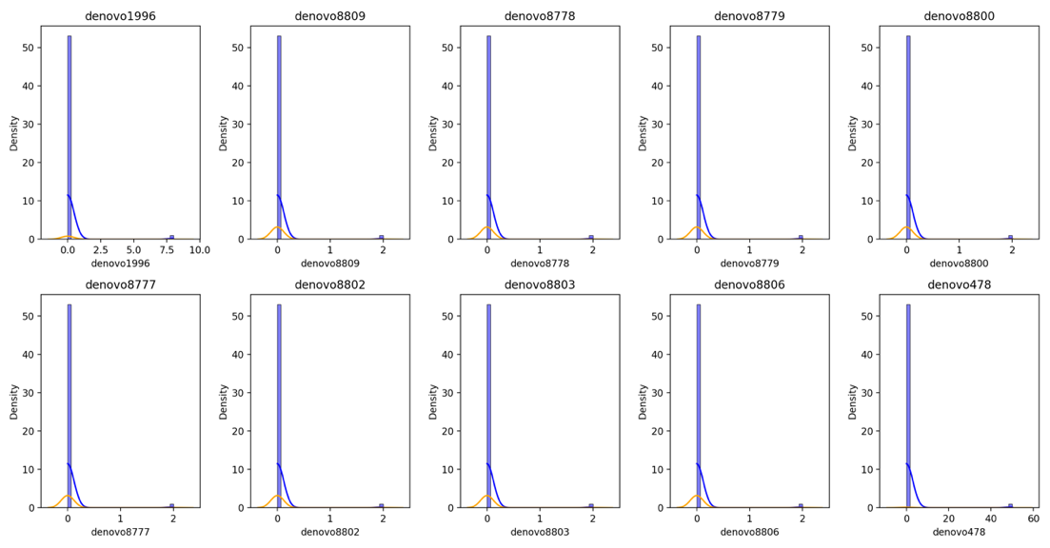

Fig. 25. Kernel Density Estimation of the Top Ten Features in the NASH-Chan Dataset

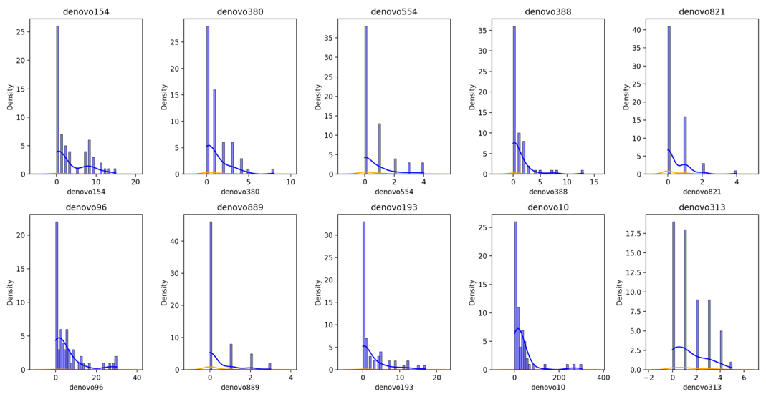

Fig. 26. Kernel Density Estimation of the Top Ten Features in the OB-Jumpertz Dataset

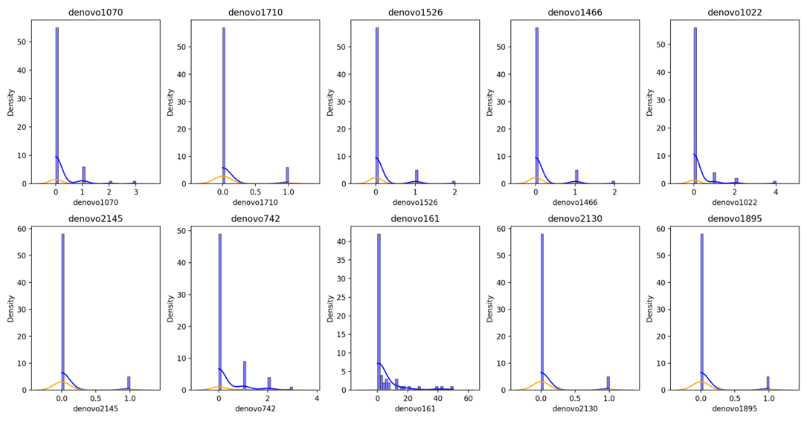

Fig. 27. Kernel Density Estimation of the Top Ten Features in the OB-Ross Dataset

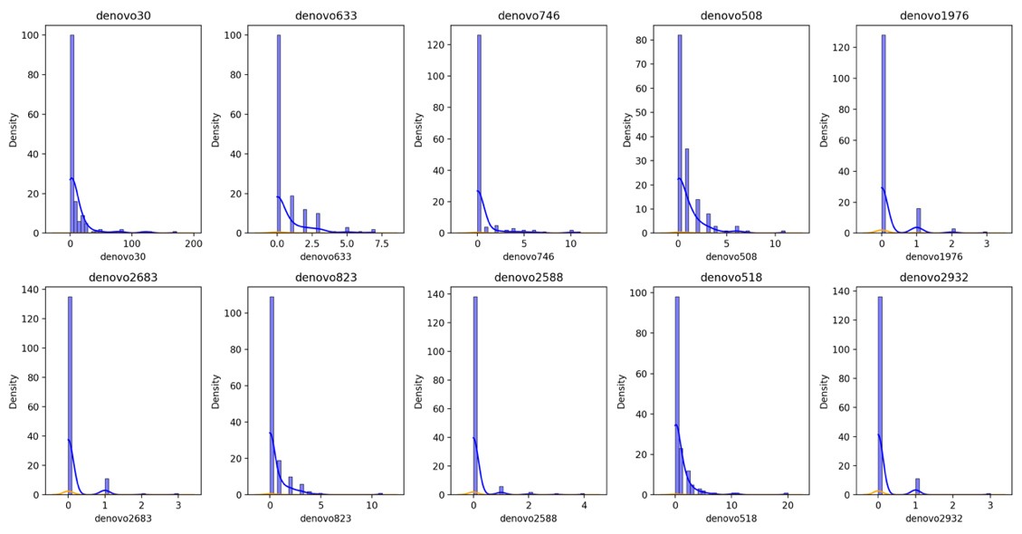

Fig. 28. Kernel Density Estimation of the Top Ten Features in the PAR-Scheperjans Dataset

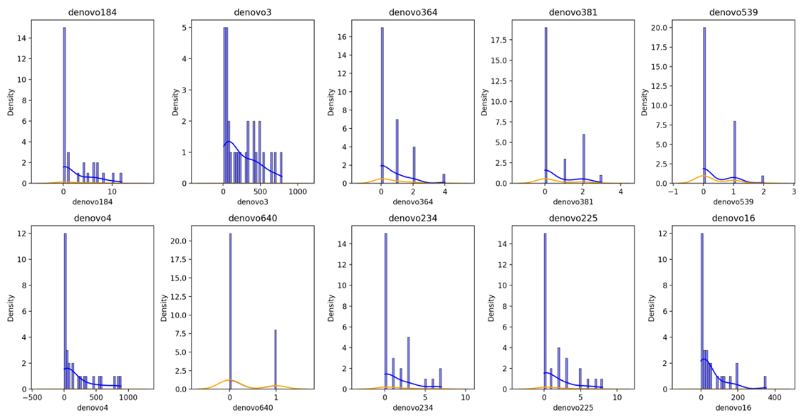

Fig. 29. Kernel Density Estimation of the Top Ten Features in the T1D-MejiaLeon Dataset

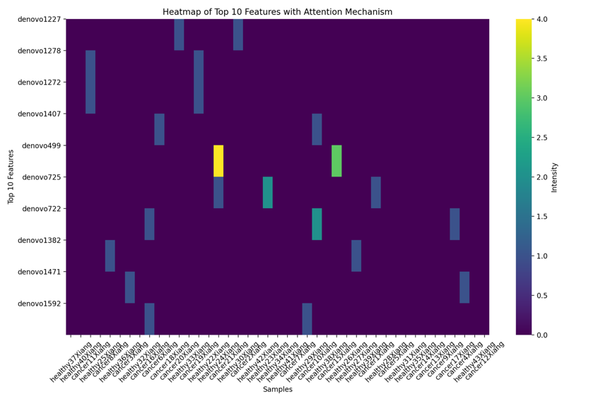

Fig. 30. Top 10 Feature Attention Heatmap for CRC-Xiang Dataset Analysis

The source literature addresses corresponding to each data set are as follows:

* **asd_son**: http://dx.doi.org/10.1371/journal.pone.0137725
* **asd_kang**: http://dx.doi.org/10.1371/journal.pone.0068322
* **cdi_vincent**: http://dx.doi.org/10.1186/2049-2618-1-18
* **crc_xiang**: http://dx.doi.org/10.1371/journal.pone.0039743
* **crc_zeller**: http://dx.doi.org/10.15252/msb.20145645
* **crc_zhao**: http://dx.doi.org/10.1038/ismej.2011.109
* **hiv_dinh**: http://dx.doi.org/10.1093/infdis/jiu409
* **hiv_lozupone**: http://dx.doi.org/10.1016/j.chom.2013.08.006
* **ibd_gevers**: http://dx.doi.org/10.1016/j.chom.2014.02.005
* **nash_chan**: http://dx.doi.org/10.1371/journal.pone.0062885
* **ob_jumpertz**: http://ajcn.nutrition.org/content/early/2011/05/03/ajcn.110.010132
* **ob_ross**: http://dx.doi.org/10.1186/s40168-015-0072-y
* **par_scheperjans**: http://dx.doi.org/10.1002/mds.26069
* **t1d_mejialeon**: http://dx.doi.org/10.1038/srep03814